<Company name> VPN network settings Form

This Network form should be filled by the “<Company name>” Commodities SA Network Security specialists in order the network equipment at both sites Athens Exchange (ATHEX) and “<Company name>” can be accordingly configured.

- General “<Company name>” information:

Company Name:
Technical Contact for Installation:
Phone:
Mobile phone:
Email:

- Network topology

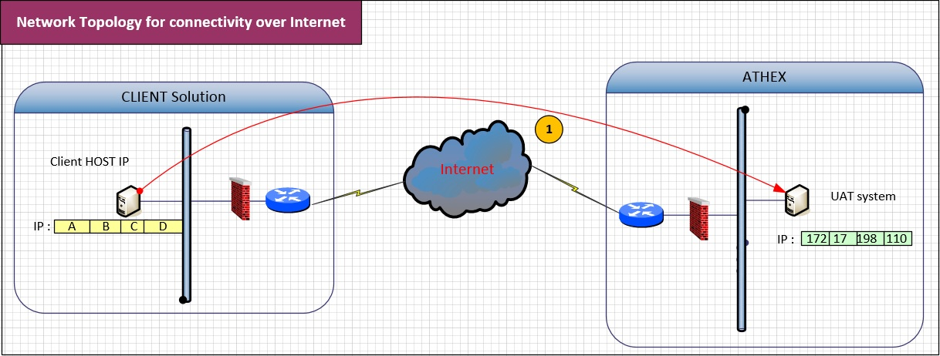

Network Diagram 1

- “<Company name>” application flows characteristics

Services and flows definition
  - “<Company name>” Integration Service for development connection
The “<Company name>” will be connecting to the GAS Server IP: 172.17.198.110 using TCP protocol (-s) at a specific port (-s) that will be provided.

According to the above Network Diagram, the application flows have the following characteristics:

Flow  ID | Application flow description | Protocol | Source IP | Source port | Destination IP | Destination Port
1 | “<Company name>” Service for UAT connection | TCP | (A.B.C.D) | gt 1023 | 172.17.198.110

Table 1, Application Flows for the Test Environment

- Network settings for “<Company name>”:

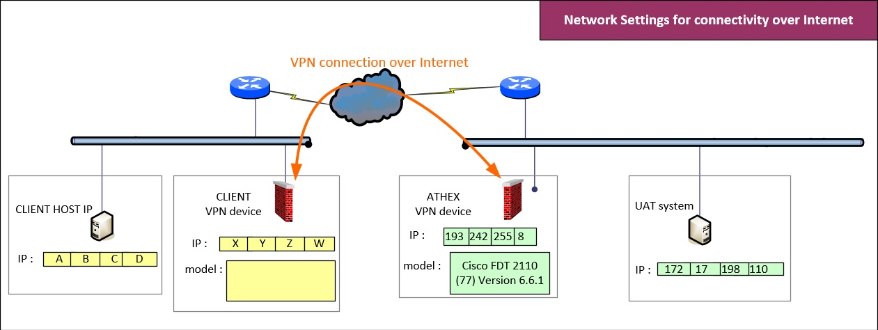

Network Diagram 2

The “<Company name>” Network Security specialist is kindly requested to fill in the missing information pertinent to Network Diagram 2; this is essential for ATHEX to proceed with the necessary arrangements that will permit the implementation of the “<Company name>” via IPSec VPN Tunnel.

  - VPN Connection parameters and setting:

The interconnection between the “<Company name>” to the ATHEX server is placed over Internet. For this reason, it is strongly recommended to establish a VPN connection between the ATHEX VPN device and the “<Company name>” VPN device.

    - VPN parameters

For the LAN-to-LAN IPSec VPN tunnel the parameters should be configured are shown in the following Table:

VPN Configuration | Policy Based
IKE Proposal
IKE Version | 2
Encryption Algorithm | AES-256
Hashing Algorithm | HMAC-SHA256
Diffie-Hellman Group | Group 20
Authentication Method | Preshared
SA Lifetime | 24 hours
IPSec Proposal
Protocol | ESP
Encryption Algorithm | AES-256
Hashing Algorithm | HMAC–SHA256
Pfs Group | Group 20
SA Lifetime | 8 hours
Preshared Secret Key ^{(*)} | TBD

Table 2, IPSec VPN tunnel parameters

^{(*)} For security reasons during the final configuration process of the IPSec VPN tunnel a different e-mail address or mobile phone number will be used, for ATHEX network dpt. to forward the Preshared Secret Key (PSK).

    - Compatibility check between ATHEX VPN and the “<Company name>” VPN device

The equipment used by ATHEX for the concentration of the LAN-to-LAN IPSec VPN connection is a Cisco FTD 2110 (this kind of equipment is fully compatible with any other Cisco device including Cisco Routers, Cisco Firewalls as well as Cisco VPN concentrators - full compatibility list can be found at the following URL:
https://www.cisco.com/c/en/us/td/docs/security/firepower/compatibility/firepower-compatibility.html

In case VPN devices other than Cisco are used, additional checks must be performed regarding the compatibility of this network equipment with the Cisco FTD 2110.

Please fill in the table below with the VPN equipment details that you plan to use.

Manufacturer | Model | Operation system version

    - IP addressing of the VPN equipment.

According to the above Network Diagram 2, the ATHEX VPN concentration equipment has the public IP address: 193.242.255.8

Please fill in the public IP address for the VPN device that will be used in test environment:

Public IP address for the VPN device (X.Y.Z.W)

In this configuration the “<Company name>” member public IP should be dedicated - static (also known as a fixed IP address) as is considered best practice when ensuring remote access for the workforce via a Lan-to-Lan IPSec tunnel.

    - Network settings for the implementation of the VPN connection

In case that Cisco equipment is used, ATHEX will be able to provide all the necessary instructions for the installation; otherwise (in case of non - Cisco equipment to be used), ATHEX will contact “<Company name>” to determine the appropriate VPN installation.

Please note that the following protocols should be permitted from the “<Company name>” network equipment to have an established VPN connection:
- IPsec Encapsulating Security Protocol (ESP) (protocol 50),
- IPsec Network Address Translator Traversal NAT-T (UDP port 4500) and
- IPsec Internet Security Association and Key Management Protocol (ISAKMP) (UDP port 500).

  - IP Address settings

    - Network settings for “<Company name>” Company test Server” to “GAS UAT Server” interconnection:

As depicted in the Network Diagram 2 above, the “GAS test Server” in ATHEX side has an IP address: 172.17.198.110.

In case that “<Company name>” will use a dedicated range of public IP addresses for the ““<Company name>” member test Server”, the exact IP address that will be reserved for the ““<Company name>” member test Server” must be specified (in the blank space below); otherwise, ATHEX will contact “<Company name>” to determine a private IP range (10.195.0.0/19) that will cause no side-effect to both networks.

“<Company name>” member test Server | <public IP addresses>
The ““<Company name>” member test Server” IP address will be NATed to the private IP address (Providing by ATHEX): | (A.B.C.D.)

- Terms and Conditions

  - The customer is responsible for obtaining all approval(s) for importing and operating their equipment, as may be required by the respective local laws and regulations.

  - Both parties are responsible for securing their respective ends of the connection against unauthorized third-party access.

